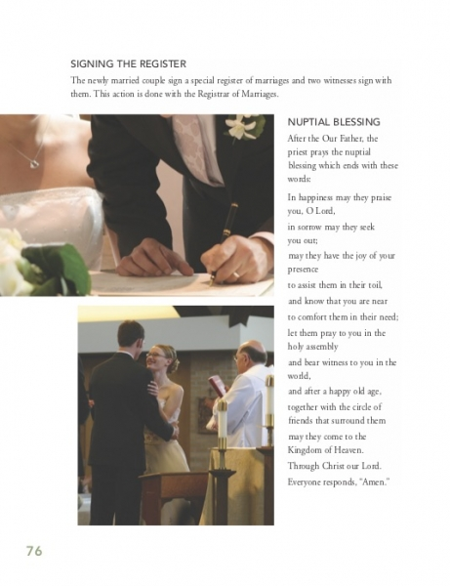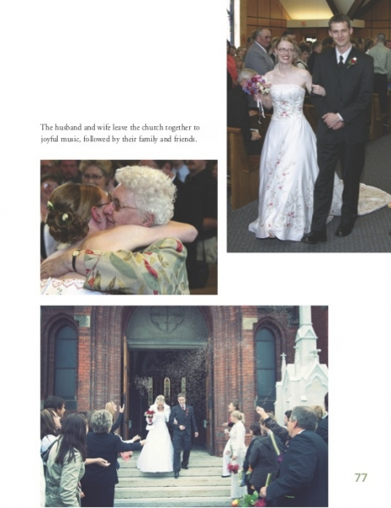

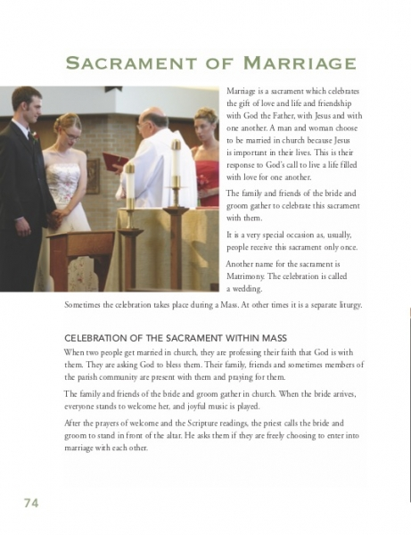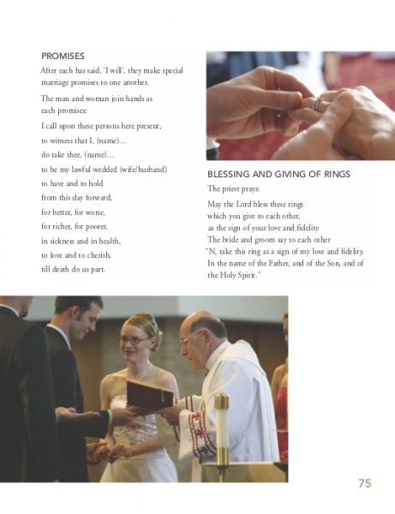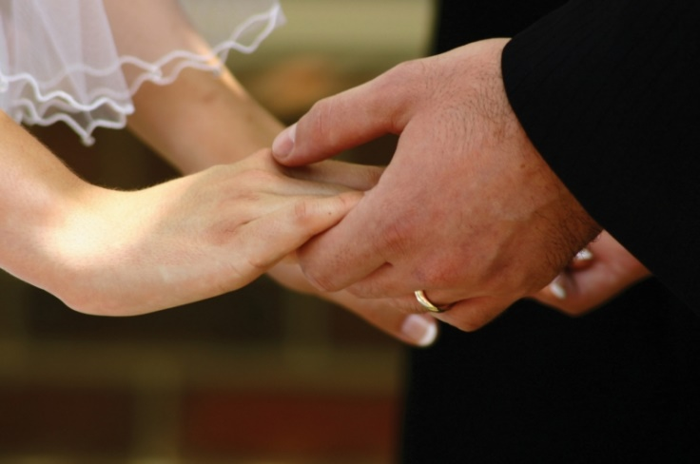

The Year 5 topic looks at the Sacrament of Marriage. You might like to use these pictures to talk to your child about the Sacrament, cut them out and use them in their topic work, or sequence them in order. (They are in a random order on this page)